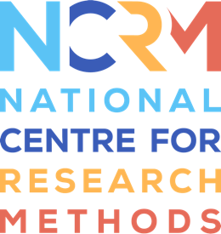
Storytelling Toolkit

Activity 3 – Show and tell

Activity three is called Show and Tell. And this one is based not just upon individuals bringing along objects with them. But it will the starting point is a display of a range of objects on the table that people can look through. So there's an experience of looking at lots of different objects. But also then people can have license to pick whatever object they want to. And these objects that they select to them the basis for the activity. And I think that offers a kind of unexpectedness about it, and that you don't know what people are going to choose or which objects are going to be the most evocative, but also a kind of openness and, you know, you're kind of open to what kind of objects people choose to really respond to.
This activity works best if it's not a new group, but a slightly more established one, because it really works if you've got a few volunteers from the group who are willing to help prepare you in advance having a few kinds of stories ready. And I think what's great about this for the volunteers is that they can respond any way they want to. So some people might have a verbal story, they want to talk about a specific memory, or someone else might want to do a short reflection or even a short poem, for example, really, whatever your volunteers want to do. And I think what happens in this activity is people will reflect on an object and how they connect to it. And also thinking maybe about what stories are evoked by this. It's about individual responses. But again, it's really centering discussion and responding to each other's memories and starting to think about the connections between those stories. So it's a really good for an established group who've got that confidence, really starting to build those connections moving forward, and also listening to each other.
You have to be quite well prepared for this, you need a good range of objects. You also need people volunteers who are ready to start the session with their own stories around the objects. And then that's a kind of inspiration that for other people to share their own stories. And the key emphasis, as I said, is on the communal thing here, so that might be discussion group discussion, where you could even get a group to do a piece of creative writing together. And one of my top tips for this one is you might want to do activity, one, collect and connect for some inspiration, both for the objects but also for which people which volunteers might want to share a story so that that combination things really works well.

National Centre for Research Methods (NCRM)
Social Sciences
Murray Building (Bldg 58)
University of Southampton
Southampton SO17 1BJ
United Kingdom
Web www.ncrm.ac.uk
Email info@ncrm.ac.uk
Tel +44 23 8059 4539
Twitter @NCRMUK

